A2619-US-MA-East Cambridge-American Chestnut Bottle-Felsite and Quartzite-1750-1850

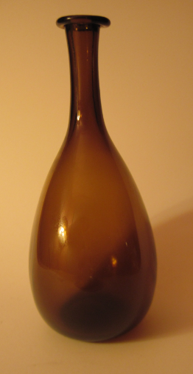 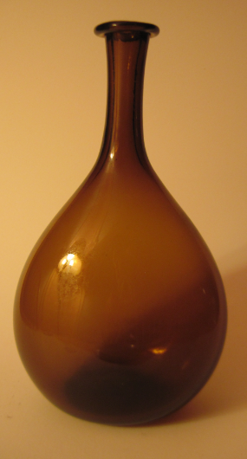

Fig. 1. Narrow side view Fig. 2. Front view

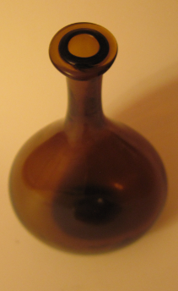 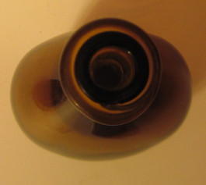

Fig. 3. ¾ view from top Fig. 4. Top view showing pre-formed 0.55 in inside dia. insert

**Case no.: 12**

**Accession Number: A2619**

**Formal Label:** US-MA-East Cambridge-American Chestnut Bottle-Felsite and Quartzite-1750-1850

**Display Description**:

The most common type of glass bottle in the colonies at the time of the American Revolution was the American Chestnut Bottle, a free-blown in a pleasingly ellipsoidal shape of the chestnut itself colored with the brown hues of the American chestnut. Why was a bottle named for the American Chestnut so popular? In colonial America, the American chestnut tree was the preferred as a species for log cabins, posts, and later, railroad ties. Where logs were prone to rotting, chestnut wood resisted water very well. The edible American Chestnut contributed to the rural economy by providing not only fodder for hogs and cattle that could meander among bountiful chestnut trees, eating their dropped chestnuts, but also an iconic favorite food accompaniment to the Thanksgiving-Christmas holiday season.

The American Chestnut Bottle ensconced this truly American heritage tree and its pleasingly chestnut-brown nut on the dining tables of thousands of admirers for two reasons. First, Figs. 1 and 2 shows how the glassblowers were able to produce the iconically beautiful ellipsoidal chestnut shape which required great expertise. Secondly, the color produced by the local iron-rich felsite and quartzite sands of New England were admirably suited to producing the hue of the American chestnut.

**LC Classification:** NK5440.B6

**Date or Time Horizon: c** 1750-1850

**Geographical Area:** East Cambridge, Massachusetts

**Map:**



Fig. 5. Detail of an 1854 map of East Cambridge. Where the word “Cambridge is placed on the map is the approximate location of the New England Glass Company. For orientation purposes, the swamp of Ward III has been landfilled and developed, Miller's River (here labeled Miller's Creek) was also landfilled and is now mainly a railroad yard, the Broad Canal follows Broadway and Portland Street, and West Boston Bridge is now Longfellow Bridge. After <https://upload.wikimedia.org/wikipedia/commons/d/d9/1854_EastCambridgeMA_map_byWalling_BPL_12775.png>



Fig. 6. Engraving of the New England Glass Company of East Cambridge, Massachusetts, by Henry Holcomb (Barnhill 1999: 190) showing the massive steam chimneys from the east in 1855 from a Boston magazine after https://upload.wikimedia.org/wikipedia/commons/c/cc/NEGC_exterior_view.jpg.

**GPS coordinates:** 42° 22′ 0″ N, 71° 4′ 48″ W

**Cultural Affiliation:** probably produced by the New England Glass Company of East Cambridge, Massachusetts, which was established by Amos Binney, Edmund Munroe, Daniel Hastings, and Deming Jarves on February 16, 1818. The company produced The American Chestnut Bottle using two furnaces and twelve pots. One of the plant’s other specialties was cut glass, and this was produced in a cutting department with 24 cutting mills run by steam power the smoke stacks of which are clearly shown in the engraving by Holcomb “sc” (the abbreviation for sculpsit," Latin for he or she sculpted it), Fig. 6, above. In 1823, 140 workers produced ten tons of glassware weekly, a great deal of which was cut-glass and sent to Boston by ship to the docks on Atlantic Avenue for sale. However, the American Chestnut Bottles continued to be a big favorite until mid-century coincident with the extinction of the American Chestnut trees in eastern North America.

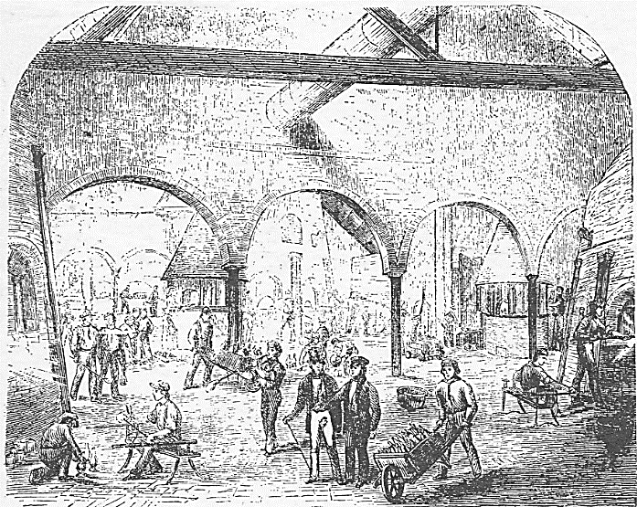

Fig. 7. The glassblowing department of the New England Glass Company, 1855, by Henry Holcomb (Barnhill 1999: 190). After

https://upload.wikimedia.org/wikipedia/commons/7/76/NEGC_glassblowing_department.jpg

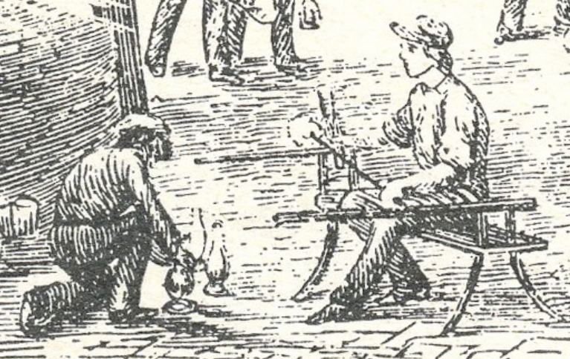

Fig. 8. Detail of the glassblowing department of the New England Glass Company, 1855, by Henry Holcomb (Barnhill 1999: 190), showing the manufacturing of American Chestnut Bottles. The figure on the right shows how the ellipsoidal chestnut shape was produced with great expertise. The figure on the left is pushing a rectangular punch into the bottom of the flask and then will grind the bottom flat. After

https://upload.wikimedia.org/wikipedia/commons/7/76/NEGC_glassblowing_department.jpg

**Medium:** raw silicon, sand

**Dimensions:** Opening at lip--1.47 in, 36.72 mm; Opening at mouth--0.55 in, 14.04 mm; Height 8.82 in, 223.94 mm; Approx. length of stem-- 2.97 in; 75.36 mm; Maximum Width on bulbous side-- 5.03 in; 127.74 mm; Maximum width on ground base-- 2.44 in, 61.96 mm; Rectangular glass punch on base--Width 0.63 in, 16.00 mm, Height 0.58 in, 14.72 mm; Ratio of Length of Stem to Height—.336.

**Weight: 1 lb, 2 1/8 oz; 514 gm**

**Condition: original**

**Provenance:** The Vose-Hillery Families, Beverly, Massachusetts

**Discussion:**

 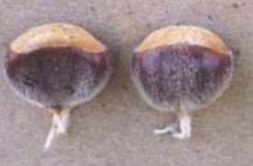 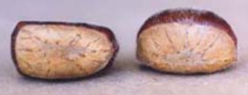

Fig 9. The natural range of the American chestnut (Castanea dentata) a large, monoecious deciduous tree of the beech family that inhabited 200 million acres of eastern woodlands, until succumbing to the pathogenic fungus Cryphonectria parasitica, a member of the Ascomycota (sac fungi) taxon. The chestnut blight caused the die-off of 4 billion American chestnut trees, during the first half of the 20th century. After <https://www.acf.org/the-american-chestnut/native-range-map/>

Fig. 10. American chestnut (Castanea dentata), side view, 0.5-1.0 in diameter. After <https://www.acf.org/wp-content/uploads/2016/09/Amer_nuts_endview.jpg>

Fig. 11. American chestnut (Castanea dentata), top view, 0.5-1.0 in diameter. After https://www.acf.org/wp-content/uploads/2016/09/Amer_nuts_endview.jpg

These bottles were made by eastern colonial glassblowers from about 1750 to 1850 in a spectrum of colors ranging from chestnut brown to olive green to depending on the sand used, but the true hue aimed at was always chestnut brown. The bottles ranged from 4 to 12 inches in height with an ellipsoidal cross-section mimicking the actual chestnut shape (McKearin 1948, pl. 225, Spillman 1983, no.45).

The proportionality of the stem to the height ranged from 2 % to 50%. The example presented here has a ratio of nearly a and this was critical if one wished to pour its contents by ounces. One could not pour out a continuous stream of liquid from the true American Chestnut Bottle because this was prevented by the length of the stem and the diameter of the mouth: each ejection of a fluid from the flask was nearly the same no matter what amount was left, and this was ensured by the second lip of dark glass that the glassblower inserted into the mouth when the stem was still red hot. This was one of the three last critical steps in manufacturing. In order to pour out approximately 2 ounces, 10 ejections of liquid were necessary. Of course, these were simple numbers to remember and multiply, especially by a tavern keeper or barmaid in a dimly lit tavern. A great selling point. The final two steps of the glassblowing process were to depress the center of the bottom with a rectangular instrument while the glass was still pliable to ensure a secure base and then to grind the remaining uneven places on the long side of the base.

**References:**

Barnhill, Georgia Brady. 2000. The Catalogue of American Engravings : a manual for users. Worcester, MA : American Antiquarian Society.

Mc Kearin, Helen. 1978. *American Bottles and Flasks and their Ancestry*. New York: Crown Publishers.

Mc Kearin, George and Helen. 1950. Two hundred years of American blown glass. Garden City, NY.

Mc Kearin, George and Helen. 1948. American Glass. New York: Crown Publishers.

Palmer, Arlene. 1989. Glass in early America: selections from the Henry Francis du Pont Winterthur Museum. Winterthur, DE: Winterthur Museum; New York: Distributed by Norton.

Palmer, Arlene. 1989. The Wistars and Their Glass 1739-1777. Millville, NJ: Museum of American Glass at Wheaton Village.

Spillman, Jane. 1982. Glass Vol. 1, *Tableware, Bowls & Vases*. New York: Knopf.

Spillman, Jane. 1983. Glass Vol. 2, *Bottles, Lamps & Other Objects*. New York: Knopf.

**Appendix:** from the [Ancient Glass Blog of The Allaire Collection](https://ancientglass.wordpress.com/)

The three examples from the Allaire collections are:

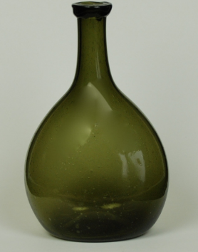

Fig. 12. 05A Chestnut Bottle H: 5 7/8 in

This is a dark olive green American chestnut bottle with pushed-up base.  Plain applied lip.

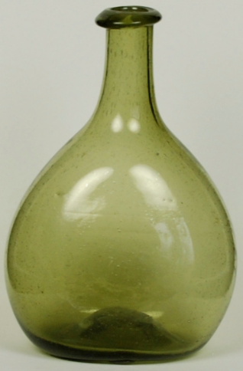

Fig. 13. 25A Chestnut Bottle H: 5 ½ inches

This is a light olive green American chestnut bottle with pushed-up base.  Plain applied lip.

[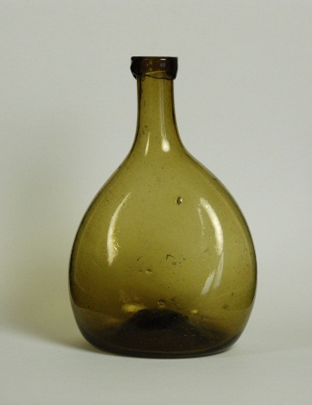](https://ancientglass.wordpress.com/2013/03/11/american-chestnut-bottle/33a-chestnut-bottle/)

Fig. 14. 33A Chestnut Bottle H: 5 ½ inches.

This is a light brown American chestnut bottle with pushed-up base.  Plain applied lip.